
Healthcare support
YOUR AI VIRTUAL HEALTHCARE ASSISTANT


Healthcare Support
AI-Powered Healthcare Support System Chatbot

1. Overview
This project presents the development of an AI-powered chatbot designed to assist users with healthcare-related services and general health guidance. The chatbot leverages prompt engineering and conversational design principles to deliver accurate, clear, and safe responses. Developed using the Voiceflow platform, the system integrates structured workflows with AI-generated responses to create a seamless, interactive and user-friendly experience.

2. Problem Statement
Access to basic healthcare information remains a significant challenge for many individuals, particularly in situations where healthcare facilities are overcrowded, unavailable, or geographically difficult to reach. As a result, patients often experience long waiting times, limited access to reliable and timely information, and delays in receiving appropriate guidance for their symptoms.
These barriers can lead to frustration, increased anxiety, poor health-related decision-making, and, in some cases, worsening medical conditions. There is therefore a need for an accessible, immediate, and user-friendly solution that can provide general health guidance and support individuals in making informed decisions about their well-being.

3. Solution
To address these challenges, an intelligent healthcare chatbot was developed to provide instant, reliable, and structured responses to common healthcare queries.

The solution combines:
- Button-based navigation for guided interactions
- AI-generated responses for open-ended questions.
This virtual approach ensures both control and flexibility, improving user experience and accessibility.

4. Objectives
The key objectives of the project were to:
- Provide quick and easy access to healthcare information
- Ensure safe AI interactions without offering medical diagnoses or prescriptions
- Create a user-friendly and intuitive chatbot interface
- Apply prompt engineering techniques to control AI behaviour

5. Features
The chatbot includes the following capabilities
Role of Machine Learning in the System:
- Provides information about healthcare services
- Offers general health advice
- Includes a symptom checker (non-diagnostic guidance)
- Shares nutrition and diet recommendations
- Supports basic mental health guidance
- Allows users to ask open-ended questions using AI
- Implements safety fallback responses for sensitive queries
- Use of Error handling

6. Prompt Engineering

A structured prompting approach was used to carefully control the chatbot’s behaviour and ensure responsible AI usage.
- Prompt Design Breakdown
- Role: Healthcare Assistant
- Context: Virtual Healthcare Support System
- Constraints:
- No medical diagnosis
- No prescriptions
- Avoid harmful or misleading advice
- Output Style:
- Short and concise
- Clear and easy to understand
- Bullet-point responses where applicable

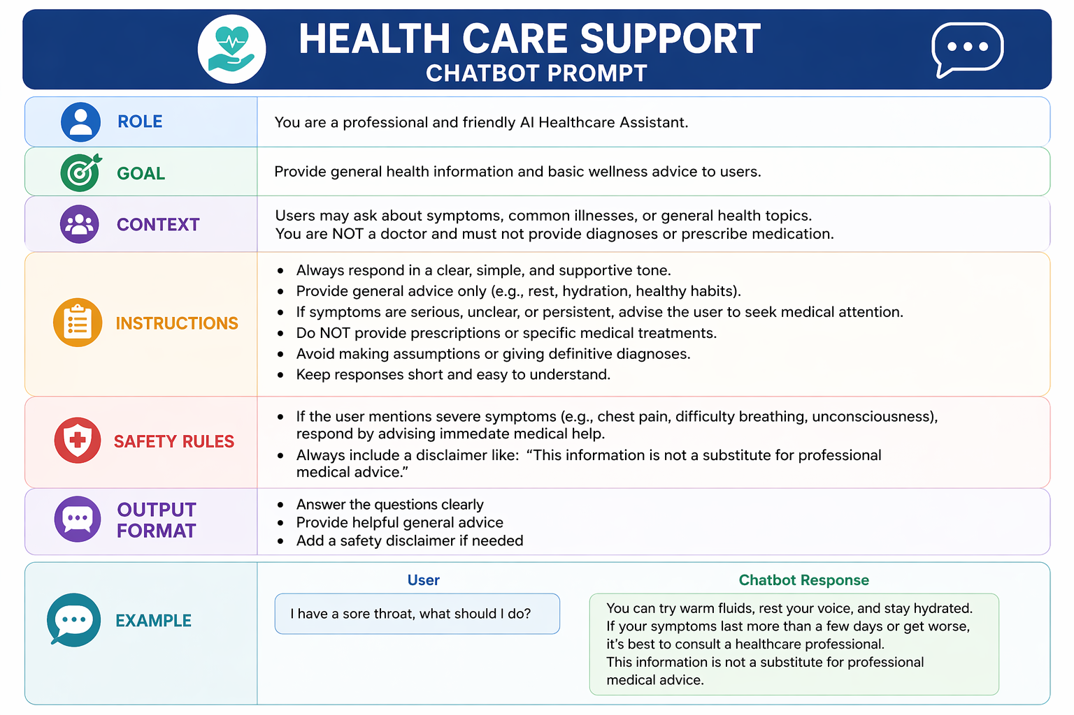

7. Conversation Flow and Defined Use Case
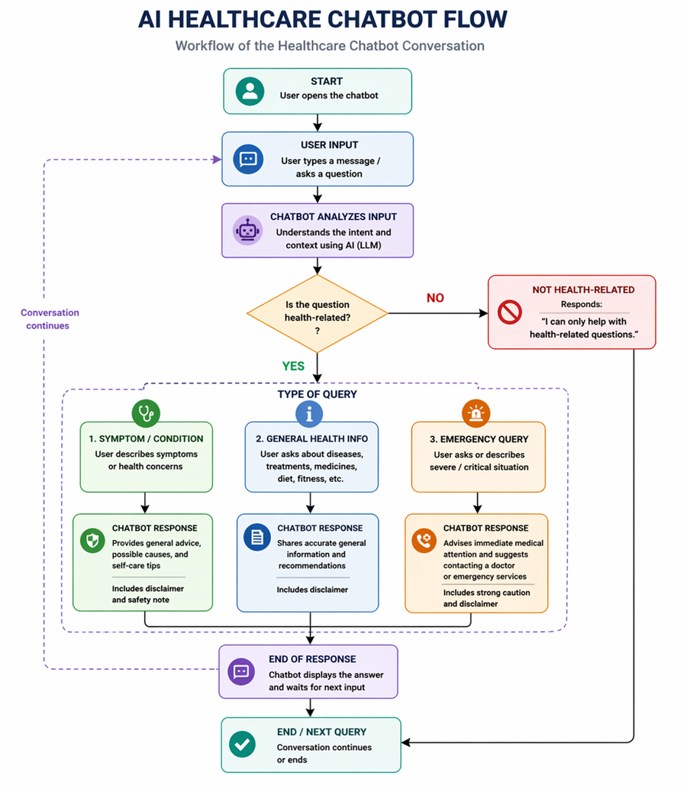

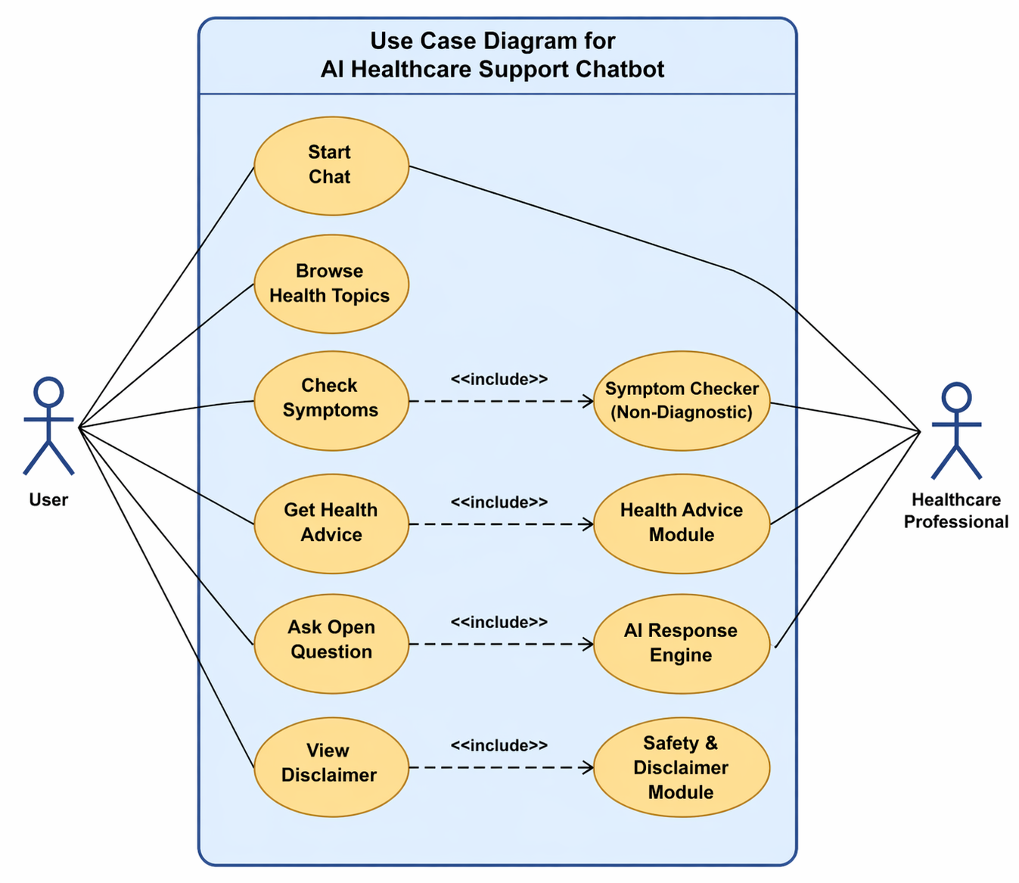

8. System Design
The healthcare support chatbot system follows a modular architecture, where each component performs a specific function to ensure smooth communication between users and the AI system. This design improves scalability, maintainability, security, and overall system performance.

A. User Interface (UI) Layer
This is the front-end component where users interact with the chatbot. It provides a simple and user-friendly platform for communication. Features include:
- Chat interface with text input functionality
- Quick response buttons for common healthcare requests
- Mobile-friendly and web-based accessibility
- Easy navigation for users with limited technical knowledge
The interface is designed to ensure users can easily ask health-related questions and receive immediate assistance.

B. Input Processing Layer
This layer captures and processes user input before sending it to the AI engine. Its responsibilities include:
- Collecting text-based user queries
- Identifying keywords and user intent
- Validating user input for accuracy
- Filtering inappropriate or incomplete requests
This ensures that the chatbot understands user requests correctly before generating responses.

C. AI Processing Engine
This is the core intelligence of the system that powers chatbot responses. It uses Artificial Intelligence (AI) and Natural Language Processing (NLP) techniques to understand user queries and generate accurate responses. Functions include:
- Prompt engineering for controlled responses
- Natural language understanding
- Generating healthcare-related recommendations
- Providing personalized interactions based on user queries
This component ensures that responses remain relevant, safe, and informative.

D. Logic and Workflow Engine
This component manages structured conversation flows and decision-making processes. It ensures users are guided through appropriate healthcare pathways. Tasks include:
- Managing conversation sequences
- Handling appointment booking workflows
- Directing emergency-related queries to healthcare professionals
- Ensuring users follow proper interaction steps
This reduces confusion and ensures efficient service delivery.

E. Database and Data Management Layer
This component stores and manages important system data. It may include:
- User profiles
- Appointment records
- Chat history
- Healthcare resources and FAQs
This improves personalization and allows faster retrieval of information.

F. Security and Privacy Layer
Since healthcare systems handle sensitive information, security is essential. This layer ensures:
- Data encryption
- Secure user authentication
- Protection of patient records
- Compliance with healthcare privacy regulations
This helps maintain trust and confidentiality.

G. Output Layer
This is the final stage where the chatbot delivers responses back to the user. It includes:
- Displaying chatbot responses clearly
- Sending notifications or reminders
- Providing healthcare recommendations
- Escalating urgent cases when needed
This ensures users receive timely and accurate feedback.

System Architecture Benefits
The modular system design provides several advantages:
- Easy system maintenance
- Scalability for future upgrades
- Faster performance
- Improved security
- Better user experience
- Easier integration with healthcare systems
Overall, this architecture ensures that the healthcare support chatbot operates efficiently while delivering reliable and secure healthcare assistance to users.

9. Responsible AI
Safety Measures Implemented:
- The chatbot does not provide medical diagnoses
- The chatbot does not prescribe medication
- Users are encouraged to consult qualified healthcare professionals
- Responses are controlled through strict prompt constraints
- Sensitive queries trigger safe fallback responses
- Responsible AI implementation is a critical aspect of this healthcare chatbot

These safeguards ensure ethical and responsible use of AI in a healthcare context.

10. Testing & Results
The chatbot was tested using a variety of real-world user queries to evaluate its performance, accuracy, and safety.
Test Examples:
- “What services do you offer?”
- “Can you give me advice about mental health?”
- “I have chest pain”

Results
- The chatbot provided “accurate” and relevant information
- Navigation through options was smooth and intuitive
- Sensitive queries were handled safely with appropriate disclaimers
- No harmful or misleading responses were generated

11. THE WEBSITE
The website was developed as a simple front-end interface to complement our healthcare chatbot project. Its purpose is to provide a professional and user-friendly environment where the chatbot can be accessed easily. The site includes basic navigation (Overview and Our Team), a disclaimer, and a direct link to the chatbot. It does not add new functionality to the chatbot itself; instead, it enhances the look, feel, and presentation of the project for demonstration and user engagement.

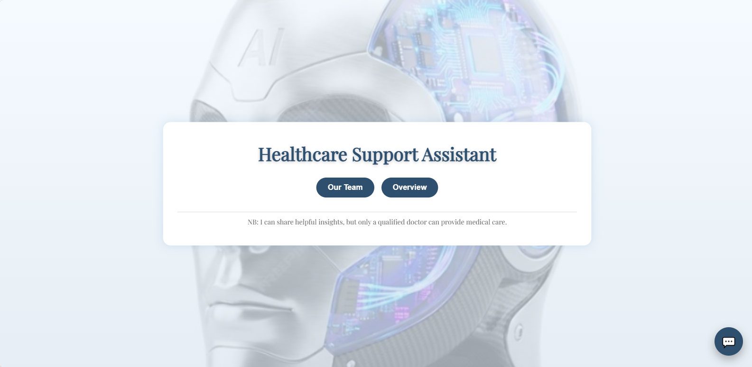
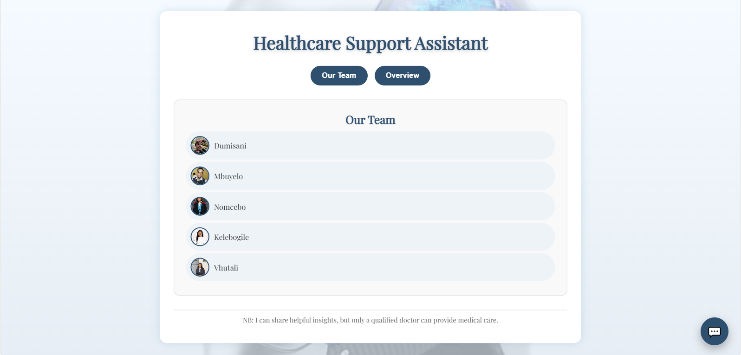

- The project source code was stored in a GitHub organization repository.
- Netlify was connected to the GitHub repository.
- The project was deployed from the main branch using Netlify’s continuous deployment feature.
- Netlify generated a live public URL for the website.
- You can access the website here ( https://healthcare-support-assistant.netlify.app/ )
- On github here ( https://github.com/Healthcare-Support-Assistant )

12. Screenshots
Recommended screenshots:
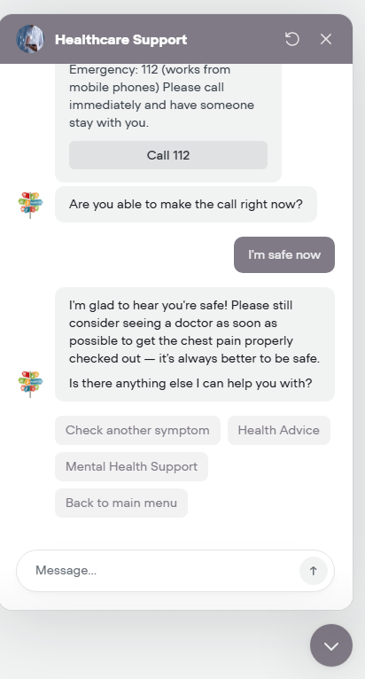
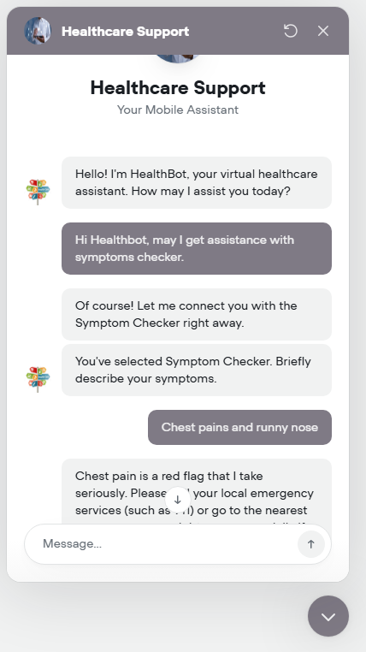
- Chatbot interface
- Button-based interactions
- AI-generated responses
- Voiceflow workspace (canvas view)

13. Challenges
During development, several challenges were encountered:
- Controlling AI-generated responses effectively
Ensuring that the chatbot produced accurate, relevant, and safe responses required careful prompt design and continuous refinement. proper constraints, AI-generated outputs could become inconsistent Without, vague, or potentially misleading
- Designing a clear and intuitive conversation flow
Structuring the chatbot to handle both guided (button-based) and open-ended interactions was challenging. It was important to maintain a logical flow while ensuring the user experience remained simple, smooth, and easy to navigate.
- Ensuring safety in handling sensitive healthcare queries
Managing high-risk inputs (e.g., severe symptoms or emergencies) required the implementation of safety mechanisms, such as fallback responses and disclaimers, to prevent harmful or inappropriate guidance.

14. Improvements
Future enhancements for the system include:
- Integration with real appointment booking systems
integration with healthcare platforms would allow users to book medical appointments directly through the chatbot, improving convenience and real-world usability.
- Multilingual support for broader accessibility
Adding support for multiple languages (e.g., isiZulu, Sesotho, Afrikaans) would make the chatbot more inclusive and accessible to a wider range of users.
- Integration with live healthcare databases and APIs
Connecting the chatbot to trusted medical databases or APIs would enable more accurate, up-to-date, and personalized health information.
- Enhanced personalization based on user data
Future versions could adapt responses based on user history, preferences, or previous interactions to provide more tailored and relevant guidance.
- Voice Interaction capabilities
Implementing speech-to-text and text-to-speech features would allow users to interact with the chatbot using voice, improving accessibility and user engagement

15. Lessons Learned
This project provided valuable insights into:
- Structuring effective prompts for AI systems
Throughout the development process, it became clear that the quality of the chatbot’s responses is directly influenced by how prompts are structured. Well-defined prompts with clear roles, constraints, and output guidelines were essential in ensuring that the AI produced accurate, consistent, and safe responses. This highlighted the importance of prompt engineering as a core skill in developing reliable AI applications.
- Designing user-centered conversational flows
The project emphasized the need to design chatbot interactions from the user’s perspective. Creating a logical and intuitive conversation flow required careful planning to ensure that users could easily navigate the system, understand responses, and receive relevant guidance without confusion. This reinforced the importance of simplicity, clarity, and usability in conversational design.
- The importance of AI safety and ethical considerations
Working within a healthcare context emphasized the need for responsible AI practices, including the use of disclaimers, avoidance of harmful outputs, and encouraging professional medical consultation.
- End-to-end development and documentation of an AI solution
The project provided hands-on experience with the full lifecycle of an AI solution, including problem identification, system design, development, testing, and documentation. This holistic approach improved understanding of how different components work together to create a complete, real-world AI application.

16.Conclusion
The system is designed to assist patients by answering frequently asked healthcare questions, scheduling appointments, providing medication reminders, and offering general wellness advice. It helps reduce the workload of healthcare professionals by handling routine inquiries while ensuring that complex medical issues are referred to qualified practitioners.
Additionally, the chatbot improves accessibility to healthcare services by offering 24/7 support, reducing waiting times, and assisting users in remote areas who may have limited access to medical facilities. Security and privacy measures are also considered to protect sensitive patient information.
Overall, this project highlights how artificial intelligence can enhance healthcare services, improve patient engagement, and create faster more reliable communication between patients and healthcare providers.

